7th Grade Supply List
2024–2025

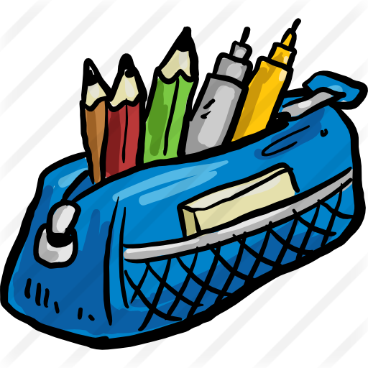
General list:
- Earbuds or headphones that can be plugged into an iPad.
- One pencil case filled with the following:
o Pens and pencils
o Highlighters
o Colored pencils
o Post-its
o Pencil sharpener
o Erasers
- Students are responsible to replenish their supplies throughout the school year in order to be prepared for class on a daily basis. Please check on their supplies regularly.

Science:
- One 2 ½ or 3-inch binder
- 7 Dividers
- Glue Sticks

Math:
- 1-inch binder
- 5 dividers
- Extra pencils!!!!

Social Studies:
- 1 inch binder with a sufficient supply of white lined paper OR a folder and a notebook

Writing Workshop:
- 1 inch binder with a sufficient supply of white lined paper OR a folder and a notebook

Language Arts:
- 2-inch binder with some white lined paper and 3 dividers

Math Explorations
- One-inch three-ring binder
- 5 subject dividers
- Pencils

World Language:
- Ipad fully charged each day. (Important)
- Ipad charger
- Earbuds with microphone for listening and recording activities
- One 2-inch binder and white lined paper for World Language only
- 3 section dividers
- 1 folder for World Language only. (No Accordian Folders please)
- A pouch with zipper for supplies
- Pens and pencils
- A highlighter (any color)
- 2 low odor dry erase markers
- A set of coloring supplies (crayons, colored pencils and markers)
- A set of colored or white index cards

Physical Education:
For all incoming 6th, 7th and 8th graders changing for Physical Education is optional. The school provides lockers however, the student must have a combination lock to secure all valuables during class if they are changing. Students may wear shorts, t-shirts, sweatpants, or sweatshirts and sneakers. If a student is not changing, sneakers are still required. Sneakers are the only proper footwear for Physical Education. Students are also recommended to bring in some form of antiperspirant or deodorant (sprays are not allowed).

Locks:
- You will need two combination locks, one for your hall locker and one for your gym locker (if changing). Key locks are discouraged since keys are easy to get lost.
Students are responsible to replenish their supplies throughout the year in order to be prepared for class on a daily basis.
Please purchase only these necessities to get you started. Each teacher will notify you of any other supplies that are needed for special projects or activities as they come up throughout the school year.

We hope that you enjoy the rest of your summer, and we look forward to working with you this year!

Sincerely,

Your 7th Grade Teachers

